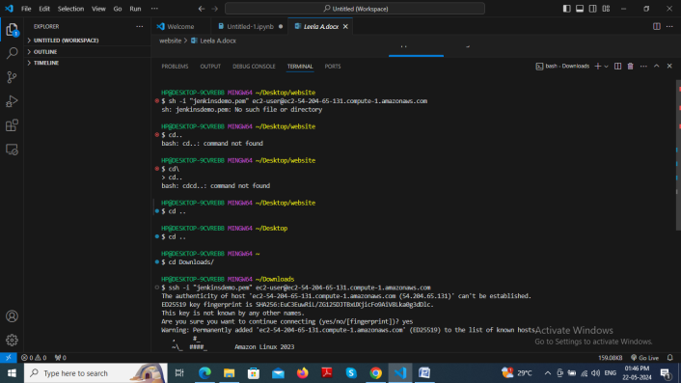

Error-> sh: jenkinsdemo.pem: No such file or directory.

It says there is no .pem file in that directory make sure the path is correct. We have write the path where the .pem file is their.

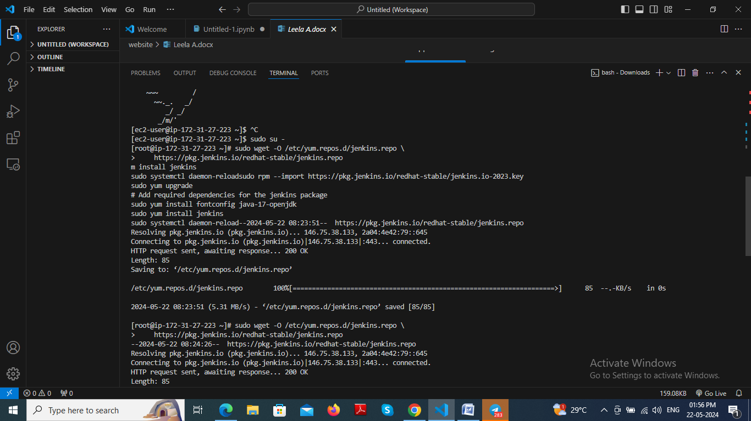

When I try to run all codes at one I will get this error.

But if I run single code one by one it will install.

sudo wget -O /etc/yum.repos.d/jenkins.repo \

https://pkg.jenkins.io/redhat-stable/jenkins.repo

sudo rpm --import https://pkg.jenkins.io/redhat-stable/jenkins.io-2023.key

sudo yum upgrade

*# Add required dependencies for the jenkins package*

sudo yum install fontconfig java-17-openjdk

sudo yum install jenkins

sudo systemctl daemon-reload

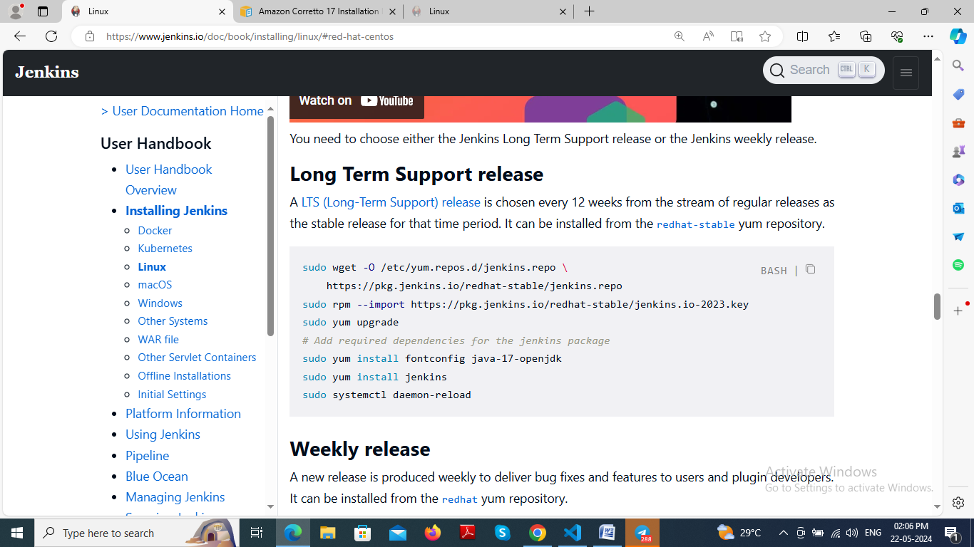

to install java go to this link for codes

[Amazon Corretto 17 Installation Instructions for Amazon Linux 2 and Amazon Linux 2023 - Amazon Corretto 17](https://docs.aws.amazon.com/corretto/latest/corretto-17-ug/amazon-linux-install.html)

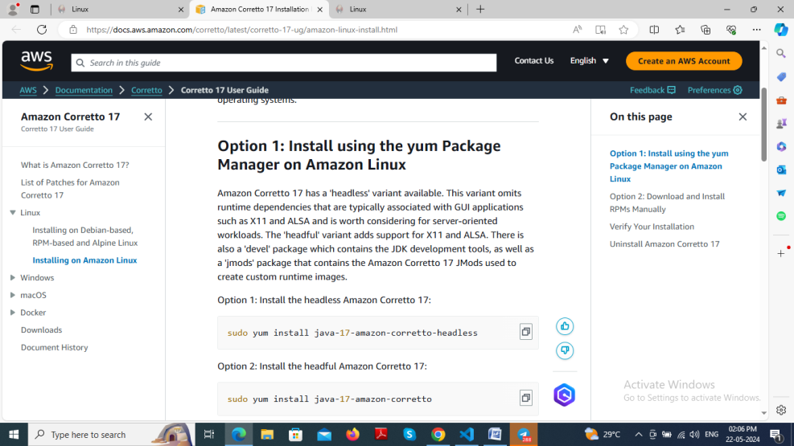

We have to copy the this part to get the password

/var/lib/jenkins/secrets/initialAdminPassword

Then type

Cat /var/lib/jenkins/secrets/initialAdminPassword

You will get the password

8f8e7b424886435480aa3ddf7f59da5d

